A
Project Report
on

Footstep Electricity Generation System

(Piezoelectric Energy Harvesting from Human Footsteps)

BTech IT, Sem II

Prepared By:

Siddhi Patel (Roll No. IT-127)
Devanshi Solanki (Roll No. IT-131)
Jiyanshi Soni(Roll No. IT-132)

Guided By:
Prof.Kunal.J.Sahitya
Dept. of Information Technology

Department of Information Technology
Faculty of Technology,
Dharmsinh Desai University
College Road, Nadiad - 387001

April, 2026
CANDIDATE'S DECLARATION

We declare that the 2nd semester report entitled "Footstep Electricity Generation System" is our own work conducted under the supervision of the guide Prof. Kunal.J.Sahitya

We further declare that to the best of our knowledge the report for B.Tech. II semester does not contain part of the work which has been submitted either in this or any other university without proper citation.

Candidate's Signature

Candidate's Name: Siddhi Patel (Roll No. IT-127)
Student ID: ITUOZ127

Candidate's Signature

Candidate's Name: Devanshi Solanki (Roll No. IT-131)
Student ID: ITUCS131

Candidate's Signature

Candidate's Name: Jiyanshi Soni(Roll No. IT-132)
Student ID: ITUOS132

DHARMSINH DESAI UNIVERSITY
NADIAD-387001, GUJARAT

CERTIFICATE

This is to certify that the project carried out in the subject of Project-I, entitled "Footstep Electricity Generation System" and recorded in this report is a bonafide report of the work of

1) Siddhi Patel (Roll No. IT-127) ID No: ITUOZ127
2) Devanshi Solanki (Roll No. IT-131) ID No: ITUCS131
3) Jiyanshi Soni(Roll No. IT-132) ID No: ITUOZ132

of Department of Information Technology, semester II. They were involved in project work during academic year 2025-2026.

Prof.Kunal . J . Sahitya
(Project Guide),
Department of Information Technology,
Faculty of Technology,
Dharmsinh Desai University, Nadiad
Date:

Prof. (Dr.)V. K. Dabhi
Head, Department of Information Technology,
Faculty of Technology,
Dharmsinh Desai University, Nadiad
Date:
ACKNOWLEDGEMENT

We extend our heartfelt gratitude to the Department of Information Technology, Dharmsinh Desai University, for providing us with the necessary resources, support, and an encouraging environment to undertake our project journey.

We sincerely thank our project guide, Prof. Kunal . J . Sahitya, for their unwavering support, insightful feedback, and invaluable guidance throughout the development of our project, "Footstep Electricity Generation System". Their mentorship played a crucial role in shaping our understanding and successfully bringing this project to fruition.

We also express our deep appreciation to our Head of Department, Prof. (Dr.) V. K. Dabhi , for fostering a culture of innovation and continuous learning, and for their constant encouragement and support.

Lastly, we are grateful to all the faculty members and staff of the Information Technology Department for their guidance, as well as to our peers and classmates, whose feedback and motivation were instrumental throughout this journey.

Siddhi Patel (Roll No. IT-127)
Devanshi Solanki (Roll No. IT-131)
Jiyanshi Soni(Roll No. IT-132)

B. Tech Semester II
Department of Information Technology
Dharmsinh Desai University
TABLE OF CONTENTS

No. | Title | Pg. No.
1. | Abstract | 6
2. | Chapter 1: Introduction | 7
3. | Chapter 2: Project Management | 9
4. | Chapter 3: System Requirements Study | 11
5. | Chapter 4: System Analysis | 13
6. | Chapter 5: System Design | 14
7. | Chapter 6: Implementation Environment | 18
8. | Chapter 7: Testing | 22
9. | Chapter 8: User Manual | 24
10. | Chapter 9: Limitations and Future Enhancements | 26
11. | Chapter 10: Conclusion and Discussion | 27
12. | References | 29

ABSTRACT

The Footstep Electricity Generation System is an innovative energy harvesting project that converts the mechanical energy from human footsteps into usable electrical energy using piezoelectric transducers. With rising global energy demands and a push for renewable energy sources, harvesting energy from human motion represents a promising and sustainable approach to supplementing conventional power systems.

This project demonstrates a working prototype of a piezoelectric floor tile system that generates electricity when subjected to the pressure of human footsteps. The system consists of an array of 8 piezoelectric disc sensors mounted on a pressure-sensitive platform, connected to a charge-accumulation and rectification circuit, a power management module, and a rechargeable battery storage unit. An Arduino Nano microcontroller monitors and displays the generated voltage and step count on an LCD display in real time.

This documentation provides a comprehensive overview of the project, covering its system architecture, hardware design, circuit implementation, testing methodology, and future enhancement plans. It is intended for students, researchers, academic institutions, and stakeholders seeking in-depth insights into piezoelectric energy harvesting for sustainable infrastructure applications.

Chapter 1: Introduction

1.1 Project Overview
The Footstep Electricity Generation System is a hardware-based project that harnesses mechanical energy from human footsteps using piezoelectric transducers and converts it into electrical energy. The system is designed to be embedded in high-footfall areas such as railway stations, shopping malls, school corridors, and public walkways, where a large number of people walk every day.

The platform provides:
- Piezoelectric tile array: 8 piezo disc sensors arranged in a 2x4 grid to maximize energy capture per footstep.
- Arduino-based monitoring: Real-time display of generated voltage and cumulative step count on a 16x2 LCD module.
- Power management: A dedicated charge pump and rectifier circuit to condition the generated AC into usable DC power.
- Battery storage: Rechargeable 18650 Li-ion cells with a TP4056 charging module to store harvested energy.
- LED indicator array: Visual feedback showing energy generation activity.

1.2 Project Objectives
The primary goals of the Footstep Electricity Generation project include:
- Demonstrate piezoelectric energy harvesting: Validate the feasibility of generating electricity from human footsteps using low-cost piezo discs.
- Design an efficient charge accumulation circuit: Maximize energy extraction and minimize losses through proper rectification and smoothing.
- Implement real-time monitoring: Display voltage output and footstep count to measure system performance.
- Ensure portability and scalability: Build a modular prototype that can be scaled up for real-world deployment.
- Promote sustainable energy awareness: Raise awareness about unconventional renewable energy sources.

1.3 Scope and Technologies Used
The project is a complete embedded hardware system with real-time monitoring capabilities.

Hardware Components:
- Piezoelectric Disc Sensors (27mm, 8 units): Primary energy transducers converting mechanical pressure to electrical charge.
- Arduino Nano: Microcontroller for signal monitoring, step detection, and display control.
- TP4056 Charging Module: Li-ion battery management and protection circuit.
- 18650 Li-ion Batteries (2 cells): Energy storage for harvested electricity.
- 16x2 LCD Display (JHD 162A): Displays voltage output and step count.
- Bridge Rectifier (IN4007 Diodes): Converts AC piezo output to DC.
- Capacitors and Resistors: Smoothing and voltage conditioning components.
- LED Strip: Visual energy indicator.

Software/Firmware:
- Arduino IDE: Firmware development environment for the Arduino Nano.
- C/C++ (Arduino): Programming language used for the monitoring firmware.
- LiquidCrystal Library: Arduino library for LCD control.

Chapter 2: Project Management

2.1 Development Methodology
The project follows an iterative hardware development methodology, which emphasizes prototyping, testing, and refinement at each stage. This approach is well-suited for embedded hardware projects as it allows systematic validation of each subsystem before full integration.
- Modular development: Each subsystem (piezo array, rectifier, power management, monitoring) was designed and tested independently before integration.
- Iterative prototyping: Multiple iterations of the tile layout and circuit were built and tested to optimize energy output.
- Version control for firmware: All Arduino firmware revisions were tracked for easy rollback and comparison.
- Continuous testing: Circuit performance was measured at each development stage using a multimeter and oscilloscope.

2.2 Team Structure
The project was developed by a three-member team with defined responsibilities:
- Hardware Designer & Circuit Engineer: Responsible for designing the piezoelectric tile layout, rectifier circuit, power management module, and physical assembly of the prototype.
- Embedded Systems Developer: Responsible for Arduino firmware development, LCD interface programming, sensor signal processing, and system integration testing.

All team members shared responsibilities for testing, documentation, and final integration.

2.3 Timeline and Milestones
The development of the project follows a structured timeline with key milestones:
- Week 1 - Research & Component Selection: Literature review on piezoelectric energy harvesting, selection of components, and procurement.
- Week 2 - Circuit Design: Design of rectifier, charge pump, and power conditioning circuits on paper and simulation.
- Week 3 - Prototype v1 - Single Piezo Test: Testing energy output of a single piezo disc and validating rectification.
- Week 4 - Piezo Array Construction: Assembling 8 piezo sensors in parallel on the tile platform.
- Week 5 - Power Management Integration: Integrating TP4056 module and battery storage into the circuit.
- Week 6 - Arduino Firmware Development: Writing and testing firmware for voltage monitoring and step detection.
- Week 7 - LCD & LED Integration: Connecting the LCD display and LED indicator strip to the monitoring circuit.
- Week 8 - Full System Integration & Testing: Combining all subsystems and conducting comprehensive performance testing.
- Week 9 - Enclosure & Physical Finishing: Mounting all components on the yellow base board and finalizing the prototype casing.
- Week 10 - Documentation & Reporting: Final documentation, result analysis, and report preparation.

2.4 Project Scheduling
A Gantt chart approach was used to track development progress across the 10-week timeline. Each subsystem's milestones were monitored weekly to ensure timely completion and to identify any bottlenecks in hardware procurement or assembly.
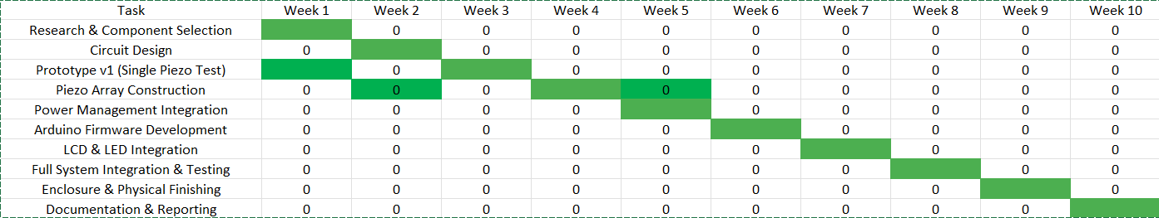

Chapter 3: System Requirements Study

3.1 Functional Requirements
The system must fulfill the following functional requirements:

1. Energy Harvesting
- The piezoelectric tile array must generate measurable electrical energy when subjected to human footstep pressure.
- The system must collect and accumulate charge from all 8 piezo discs simultaneously.
- The output must be rectified and conditioned to provide a stable DC voltage.

2. Real-time Monitoring
- The system must measure and display the instantaneous voltage generated.
- A step counter must detect and count each footstep event.
- Data must be updated and displayed on the LCD in real time.

3. Energy Storage
- Harvested energy must be stored in the Li-ion battery pack for later use.
- The charging module must protect the battery from overcharge and over-discharge.

4. Visual Indication
- The LED indicator must illuminate when energy is being generated.
- The LCD must display both voltage and step count readings clearly.

5. Physical Design
- The tile platform must be rigid enough to withstand repeated footstep pressure.
- All components must be securely mounted and safely insulated.

3.2 Non-Functional Requirements

Performance
- The system must generate a minimum of 5V peak open-circuit voltage from a single firm footstep.
- The LCD must update within 500 ms of a step event.
- The circuit must operate continuously without thermal overload.

Safety
- All exposed conductors must be properly insulated.
- The battery charging circuit must include overcharge and short-circuit protection.
- The tile surface must be slip-resistant and mechanically stable.

Scalability
- The design must support easy addition of more piezo discs to increase output.
- The monitoring firmware must be modifiable to accommodate additional sensors.

Reliability
- The piezo discs must withstand at least 10,000 step cycles without failure.
- The circuit must be protected against voltage spikes from piezo transients.

Usability
- The LCD display must be clearly readable in typical indoor lighting.
- The system must require no user intervention during normal operation.

3.3 Technical Requirements

Hardware Components:
Component | Specification | Purpose
Piezo Disc Sensors | 27mm, 8 units | Primary energy transducers
Arduino Nano | ATmega328P, 5V | Microcontroller for monitoring
TP4056 Module | 1A Li-ion charger | Battery management
18650 Li-ion Battery | 3.7V, 2600mAh x2 | Energy storage
LCD Display (JHD 162A) | 16x2 characters, 5V | Real-time data display
Bridge Rectifier | IN4007 diodes, 1A | AC to DC conversion
Capacitor | 1000uF / 25V | Voltage smoothing
LED Strip | 5V, white | Energy activity indicator
CHAPTER 4: SYSTEM ANALYSIS

4.1 Requirements of the New System

4.1.1 User Requirements
- Users need a system that can generate electricity from footsteps efficiently and reliably.
- They expect real-time display of the generated energy.
- The system should be easy to use, durable, and suitable for installation in crowded areas such as railway stations, malls, and schools.
- Users require a low-maintenance and eco-friendly solution for energy generation.
- The system should provide clear information about energy production through a digital display.

4.1.2 System Requirements
- Piezoelectric sensors to convert mechanical energy into electrical energy.
- A rectifier circuit to convert AC output into DC.
- Voltage regulator to ensure stable power output.
- Rechargeable battery for storing generated energy.
- Microcontroller (Arduino Nano) to monitor and control system operations.
- LCD display (16×2) to show voltage, power, or number of footsteps.
- LEDs for visual indication of power generation.
- A durable platform capable of withstanding repeated pressure.
- Efficient wiring and circuit components for smooth operation.

4.2 Features of the New System
- Generates electricity from human footsteps using piezoelectric technology.
- Stores the generated energy in rechargeable batteries for later use.
- Displays real-time energy data on a 16×2 LCD screen.
- Provides LED indications when power is generated.
- Operates as an eco-friendly and renewable energy solution.
- Can be installed in high-footfall areas such as malls, airports, railway stations, and smart cities.
- Requires minimal maintenance and offers long operational life.
- Helps in promoting energy conservation and sustainability.
- Supports small-scale applications like lighting street lamps, charging mobile devices, and powering sensors.
- Compact, cost-effective, and easy to install.

Chapter 5: System Design

5.1 Circuit Design

The circuit consists of four interconnected modules:

Piezoelectric Array Module

• 8 piezo discs connected (positive terminals to one rail, negative terminals to the other).

• Parallel connection maximizes current output while keeping voltage consistent.

• Output: AC voltage pulses (variable amplitude, ~5-40V peak).

Rectifier and Filter Module

• Full-bridge rectifier using four IN4007 diodes arranged in a bridge configuration.

• 1000uF electrolytic capacitor across the DC output for ripple filtering.

• A 10kΩ resistor provides a discharge path to prevent charge buildup.

Power Management Module

• TP4056 Li-ion charging IC with onboard protection handles charging of two parallel 18650 cells.

• Charging current limited to 1A to protect piezo-sourced intermittent supply.

Monitoring Module

• Arduino Nano connected to a 16x2 LCD via I2C or direct parallel interface.

• Analog pin A0 reads voltage from a resistor divider across the rectifier output.

• Firmware compares sampled voltage to threshold and updates LCD and LED accordingly.

5.2 Hardware Design

The physical hardware is organized into two sections mounted on a yellow acrylic base board:

Tile Section (Right Panel)

• Dimensions: Acrylic sheet with pink anti-static foam substrate.

• 8 piezo discs arranged in a 2x 4 grid with approximately 5cm spacing.

• Each disc is glued to the foam with epoxy for mechanical stability.

• Wiring runs underneath the foam to the output terminals.

Electronics Section (Left Panel)

• Arduino Nano mounted on a half-sized breadboard for circuit flexibility.

• TP4056 charging module mounted on the upper left corner with battery holder.

• Two 18650 batteries in a dual-cell holder (parallel configuration).

• 16x2 LCD display (JHD 162A) mounted at the bottom for easy reading.

• LED indicator strip (white) along the center column for activity feedback.

5.3 Firmware Design (Arduino)

The Arduino Nano firmware implements the following logic:

• Initialization: Configure LCD, set analog reference, initialize step counter to zero.

• Sampling Loop: Read analog voltage from pin A0 every 100ms.

• Step Detection: If voltage reading exceeds threshold (e.g., 50 ADC counts), increment step counter and set LED HIGH.

• Display Update: Write voltage in mV and step count to LCD.

• LED Control: Turn LED OFF after 200ms post-step to create a flash effect.

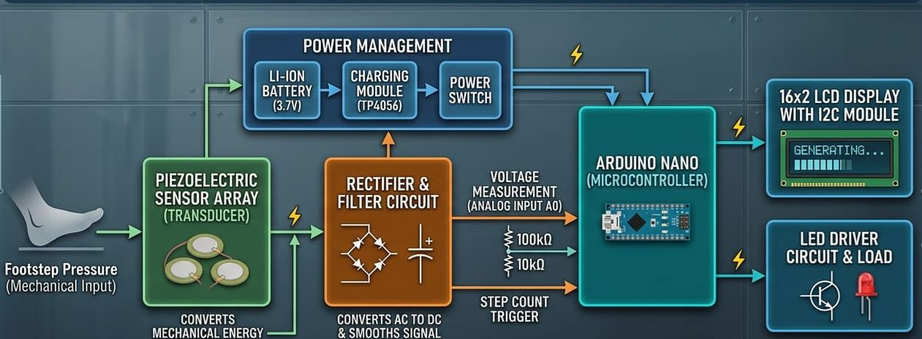

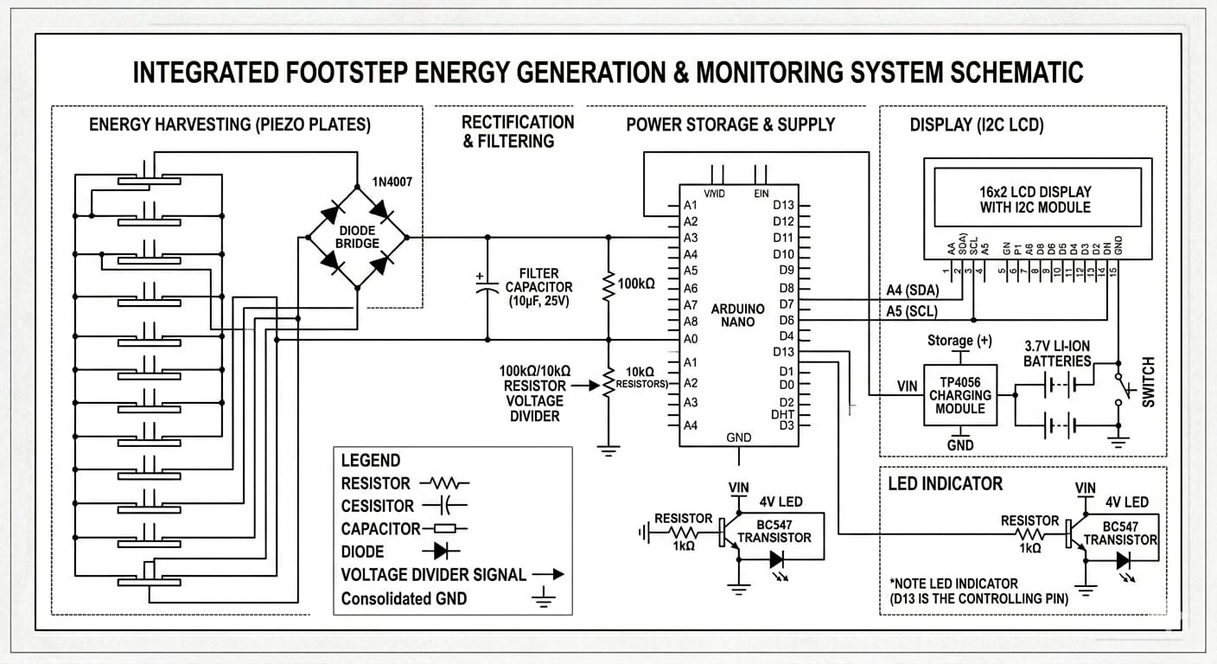
Block Diagram


Circuit Diagram

5.4 UI/UX Design (LCD Interface)

The 16x2 LCD display shows:

Line 1: "Steps:[step count]" - Cumulative step count since last reset.

Line 2: "V: [voltage]mV" - Real-time voltage reading from the piezo circuit.

The display is updated every 100ms and is clearly visible in typical indoor lighting. As shown in the prototype image, the LCD shows "steps: 0, voltage:0" when idle.

CHAPTER 6: IMPLEMENTATION PLANNING

6.1 Implementation Environment
The Footstep Energy Generation System is developed using a combination of hardware and software components to efficiently convert mechanical energy into electrical energy. The following tools and technologies were used for successful implementation.

Hardware Components
- Piezoelectric Sensors: Convert mechanical pressure from footsteps into electrical energy.
- Arduino Nano: Acts as the central controller to process and monitor system data.
- 16×2 LCD Display: Displays generated voltage, power, and footstep count.
- I2C Module: Simplifies communication between the Arduino Nano and the LCD.
- Bridge Rectifier: Converts AC output from piezo sensors into DC.
- Voltage Regulator: Maintains a stable and safe output voltage.
- Rechargeable Lithium Battery: Stores the generated electrical energy
- Lithium Charging Module (8.4V): Ensures efficient and safe battery charging.
- LED Indicators: Provide visual indication of power generation.
- Resistors and Capacitors: Used for current limiting and signal smoothing.
- BC547 Transistor: Used for switching and signal amplification.
- Diodes: Prevent reverse current flow and protect circuit components.
- Mini Breadboard and Connecting Wires: Used for circuit assembly and prototyping.
- Wooden or Metal Platform: Supports the sensors and withstands foot pressure.

Software Components
- Arduino IDE: Used for programming and uploading code to the Arduino Nano.
- Embedded C/C++: Programming language used to control system operations.
- Proteus (Optional): Used for circuit simulation and testing.
- Fritzing (Optional): Used for designing circuit diagrams.
- Windows OS: Development environment for coding and simulation.

6.2 Program / Modules Specification
The system is divided into modular components to ensure efficiency, reliability, and ease of maintenance.

1. Energy Generation Module
- Converts mechanical energy from footsteps into electrical energy using piezoelectric sensors.
- Produces voltage proportional to the applied pressure.

2. Power Conversion Module
- Converts the AC output from the sensors into DC using a bridge rectifier.
- Uses capacitors to filter and stabilize the output.

3. Energy Storage Module
- Stores the generated electrical energy in a rechargeable lithium battery.
- Ensures efficient utilization of generated power.

4. Voltage Regulation Module
- Maintains a constant voltage level to protect electronic components.
- Ensures a steady and reliable power supply.

5. Microcontroller Control Module
- Managed by the Arduino Nano.
- Monitors voltage levels and counts footsteps.
- Processes data and controls system outputs.

6. Display Module
- Uses a 16×2 LCD to display:
  - Generated Voltage
  - Energy Output
  - Number of Footsteps
- Enhances user interaction and monitoring.

7. Indicator Module
- LEDs glow when energy is generated.
- Provides a quick visual indication of system functionality.

8. Charging Module
- Uses a lithium charging module to regulate battery charging.
- Prevents overcharging and deep discharge.
6.3 Coding Standards
To ensure readability, reliability, and maintainability, the following coding standards were followed:

General Standards
- The program is written in Embedded C/C++ using the Arduino IDE.
- Meaningful and descriptive variable names are used.
- Proper indentation and formatting are maintained.
- Comments are included for better understanding and documentation.

Naming Conventions
- Variables use camelCase
- Constants are written in uppercase
- Functions use descriptive names

Modular Programming
- Code is divided into functions for better structure and reusability.
- Each module performs a specific task.
Error Handling and Safety
- Voltage limits are defined to prevent component damage.
- Proper initialization of sensors and display units is ensured.
- Noise reduction techniques are applied in sensor readings.

Sample Code Snippet
#include <Wire.h>
#include <LiquidCrystal_I2C.h>

LiquidCrystal_I2C lcd(0x27, 16, 2);

const int PIEZO_PIN = A0;
const int THRESHOLD = 2;

int stepCount = 0;
float voltage = 0;

void setup() {
lcd.init();
lcd.backlight();
Serial.begin(9600);
lcd.setCursor(0,0);
lcd.print("Footstep Energy");
delay(2000);
lcd.clear();

}

void loop() {
int rawValue = analogRead(PIEZO_PIN);

Serial.println(rawValue);

voltage = (rawValue / 1023.0) * 5.0;

if (rawValue > THRESHOLD) {
stepCount++;
delay(300);
}

lcd.clear();
lcd.setCursor(0, 0);
lcd.print("Steps:");
lcd.print(stepCount);

lcd.setCursor(0, 1);
lcd.print("V:");
lcd.print(voltage, 2);

delay(150);
}

CHAPTER 7: TESTING

7.1 Testing Plan
- Unit Testing (Sensor Module & Arduino Code)
- UI Testing (LCD Display / Output Interface)
- Integration Testing (Piezo Sensors + Circuit + Microcontroller)

7.2 Testing Strategy

- Manual & Automated Testing for sensor response and system performance.
- Electrical Testing for voltage generation and stability.
- Functional Testing for real-time energy generation and display..

7.3 Testing Methods

- White Box Testing: Internal logic validation of Arduino code and circuit connections.
- Black Box Testing: Checking output (voltage generation, display results) without internal knowledge.

7.4 Test Cases

7.4.1 Purpose
To verify each feature works correctly (footstep detection, voltage generation, energy storage, LCD display output, etc.).

7.4.2 Required Input
- Physical pressure (footsteps) applied on piezoelectric sensors
- Proper power supply to Arduino and LCD
- Circuit connections (piezo sensors, resistors, capacitors, etc.)
- Program code uploaded to Arduino

7.4.3 Expected Result
- Piezoelectric sensors generate voltage when pressure is applied
- Arduino reads and processes the generated signal correctly
- LCD displays voltage / step count / energy generated
- Energy is stored or indicated properly (if storage circuit used)
- No loose connections or incorrect readings
7.4.4 Testing Types:

Testing Type | Purpose
Unit Testing | Validates individual components such as piezoelectric sensors, Arduino code, LCD display, and rectifier circuit.
Integration Testing | Checks interaction between sensors, Arduino, energy storage circuit, and display module.
System Testing | Ensures the complete system works from footstep input to voltage generation and display output.
User Acceptance Testing (UAT) | Ensures the system works effectively in real-life conditions (walking/running on the platform) before final deployment.

CHAPTER 8: USER MANUAL

8.1 Getting Started

- System Setup: Assemble the piezoelectric sensors, connect them to the circuit, Arduino, and LCD display properly.
- Power On: Connect the system to a power source or USB and switch it on.
- Initialization: Once powered, the LCD will display system status (e.g., “Footstep Energy System Ready”).

8.2 Features & Navigation

For Operator / Admin:
- System Start: Turn on the system and ensure all components (sensors, Arduino, display) are functioning.
- Monitor Output: Observe voltage generated and step count on the LCD display.
- Check Connections: Ensure proper wiring of piezo sensors, resistors, and storage devices.
- Maintenance: Replace faulty sensors and check circuit connections regularly.

For Users:

- Step on Platform: Walk or press on the platform where piezoelectric sensors are installed.
- Energy Generation: Each footstep generates electrical energy.
- View Output: Generated voltage or step count is displayed on the LCD.
- Continuous Use: Multiple users can walk over the system to generate more energy.

8.3 Troubleshooting & Support ?

- No Output Display? Check power supply, LCD connections, and Arduino code.
- Low Voltage Generation? Ensure sufficient pressure is applied and sensors are properly connected.
- System Not Responding? Verify wiring, reset the Arduino, and re-upload the code if required.
- Need Help? Contact project guide or technician for hardware/software assistance.

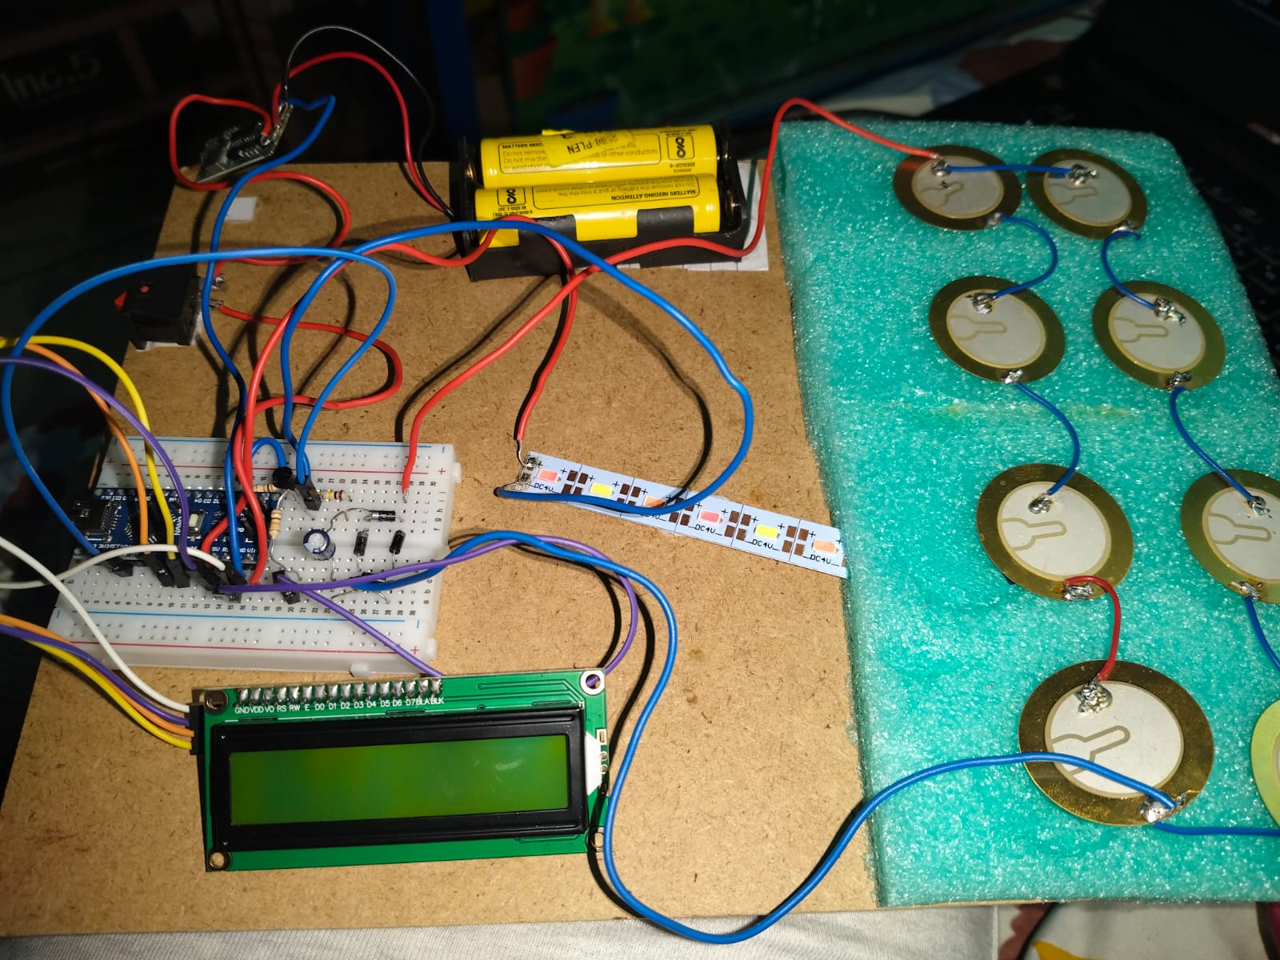
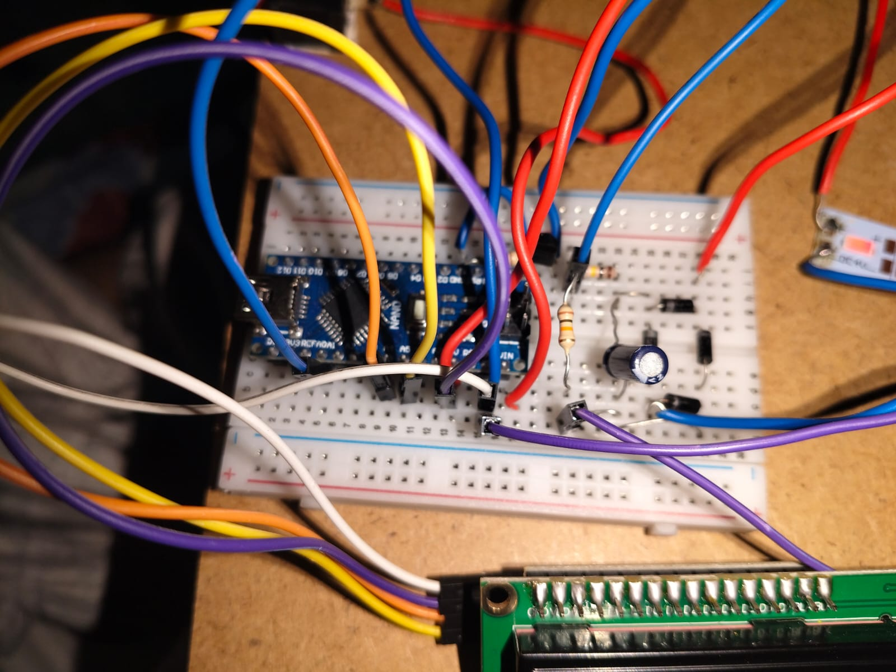
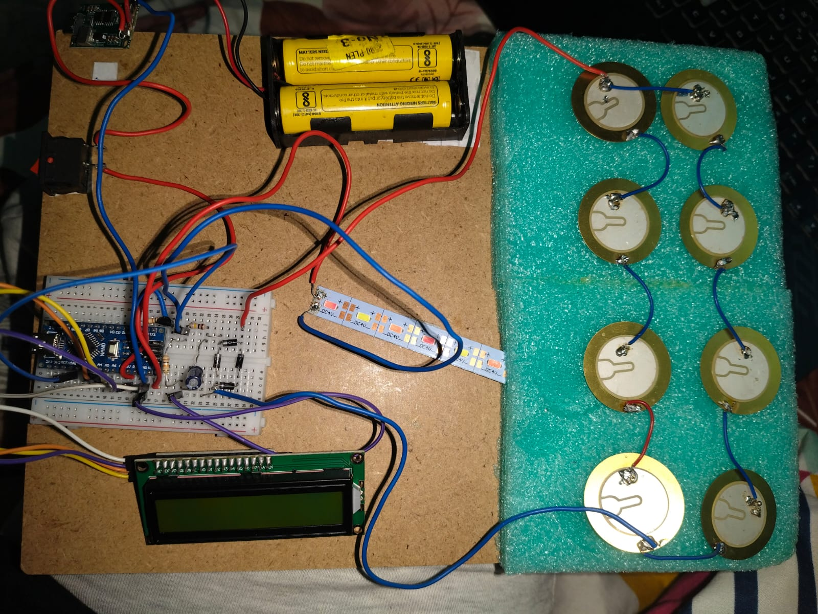

CHAPTER 9: LIMITATIONS AND FUTURE ENHANCEMENTS

9.1 Limitations
- Low Power Output: The energy generated from a single footstep is very small and not sufficient for high-power applications.
- Dependency on Pressure: Power generation depends on the force applied; light footsteps generate less energy.
- Energy Storage Limitation: Limited capacity of storage devices (battery/capacitor) restricts long-term usage.
- Durability Issues: Piezoelectric sensors may degrade or get damaged under continuous heavy load.
- Cost of Installation: Large-scale implementation (e.g., roads, malls) requires high initial cost.

9.2 Future Enhancements
- Improved Energy Storage: Use advanced batteries or supercapacitors to store more generated energy efficiently.
- Increased Efficiency: Implement better circuit design and high-quality piezo sensors for improved power output.
- Smart Monitoring System: Integrate IoT to monitor energy generation data remotely via mobile or web applications.
- Large-Scale Implementation: Install the system in high-footfall areas like रेलवे स्टेशन, malls, and footpaths for maximum energy generation.
- Hybrid Energy System: Combine piezoelectric generation with solar panels to increase total energy production.
- Wireless Data Transmission: Use Wi-Fi or Bluetooth modules to send data to cloud platforms.
- Automatic Energy Management: Develop systems that automatically store and distribute generated energy.
- Improved Sensor Design: Use flexible and more durable piezo materials for longer life.
- Real-Time Analytics: Display graphs and statistics of energy generation over time.
- Portable Models: Design compact and portable versions for small-scale or personal use.
- Smart City Integration: Integrate with smart infrastructure for sustainable urban development.

CHAPTER 10: CONCLUSION AND DISCUSSION

10.1 Conclusion
This project demonstrates the generation of electrical energy using piezoelectric sensors through human footsteps. The system successfully converts mechanical energy into electrical energy and displays the output using an Arduino-based setup. It provides an innovative and eco-friendly approach to energy generation, especially in high-footfall areas. The project highlights the potential of renewable energy sources and promotes sustainable energy solutions for future applications.

10.2 Discussion

10.2.1 Self-Analysis of Project Viability
- Efficient Energy Conversion: Successfully converted mechanical pressure from footsteps into usable electrical energy.
- Reliable Sensor Integration: Piezoelectric sensors were effectively integrated with Arduino and circuit components.
- Real-Time Monitoring: Output such as voltage or step count displayed accurately on LCD.
- Low-Cost Implementation: Used affordable and easily available components.
- Scalability Potential: System can be expanded for large-scale applications like public walkways.

10.2.2 Problems Encountered and Possible Solutions

Problem | Solution
Low voltage generation | Connected multiple piezo sensors in series/parallel to increase output
Fluctuating output signal | Used rectifier and capacitor to stabilize the voltage
Sensor damage under pressure | Used protective casing and proper mounting
Inconsistent readings | Calibrated sensors and improved circuit connections
Wiring complexity | Organized circuit layout and used proper connectors

10.2.3 Summary of Project Work
- Designed a smart energy harvesting system using piezoelectric sensors to generate electricity from human footsteps.
- Implemented piezoelectric transducers that convert mechanical stress (foot pressure) into electrical energy based on the piezoelectric effect.
- Developed an efficient energy collection circuit including rectifiers and capacitors to store and stabilize the generated voltage.
- Integrated energy storage components such as rechargeable batteries or supercapacitors for continuous power supply.
- Built a modular floor setup embedding piezoelectric plates beneath walking surfaces to capture footstep energy effectively.
- Ensured energy optimization by arranging sensors in series/parallel configurations to maximize voltage and current output.
- Designed real-time monitoring system using microcontrollers to measure generated power and display data.
- Enhanced system efficiency by reducing energy losses through optimized circuit design and load matching.
- Explored practical applications such as powering streetlights, sensors, and low-energy IoT devices in high-footfall areas.
- Planned for scalability and sustainability, focusing on smart cities, railway stations, malls, and public infrastructure deployment.

References

1. Anton, S. R., & Sodano, H. A. (2007). A review of power harvesting using piezoelectric materials (2003-2006). Smart Materials and Structures, 16(3), R1-R21.
2. Kymissis, J., Kendall, C., Paradiso, J., & Gershenfeld, N. (1998). Parasitic power harvesting in shoes. Proceedings of the 2nd IEEE International Symposium on Wearable Computers.
3. Priya, S., & Inman, D. J. (Eds.). (2009). Energy Harvesting Technologies. Springer, New York.
4. Arduino Official Documentation - https://www.arduino.cc/reference/en/
5. TP4056 Li-ion Battery Charger IC Datasheet - http://www.tp4056.com/d/tp4056.pdf
6. Ramadan, K. S., Sameoto, D., & Evoy, S. (2014). A review of piezoelectric polymers as functional materials for electromechanical transducers. Smart Materials and Structures, 23(3), 033001.
7. PiezoSystems Inc. - Piezoelectric Energy Harvesting Guide - https://www.piezosystems.com
8. Mishra, S., et al. (2019). Footstep energy harvesting using piezoelectric transducers. International Journal of Engineering Research & Technology (IJERT), 8(5).

